DEPARTMENT OF VETERANS AFFAIRS
Edward Hines, Jr. Hospital
Hines, IL 60141

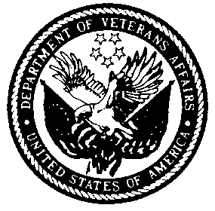

School of Nuclear Medicine Technology
Nuclear Medicine Service (115F)
Hines VA Hospital
Hines, IL 60141

PROCEDURAL GUIDELINES FOR INTERNSHIP APPLICATION

REQUIRED DOCUMENTATION

The following application documents must be received in One Complete Package;

- A completed Application for Admission form

- Official transcripts, with official school seal, from all educational institutions you attended after high school. These transcripts should include grades from your most recent quarter or semester that you have completed, and they should be sent to you directly from the school. Include these transcripts with your application package in their Original, Unopened Envelopes.

- Three educationally or professionally related letters of recommendations using the enclosed recommendation forms. The individuals who complete these forms should return them to you in unopened envelopes, signed across the seal. Include these Unopened Envelopes in your application package.

APPLICATION PROCEDURE

When we receive your completed application package, you will be contacted in writing confirming receipt of the documents. You will be instructed to contact us for a personal interview. The interview is a requirement for consideration for admission to the internship.

COMPLETE APPLICATION PROCESS DEADLINES

March 1st of each year; internship starting date is July 1st

NOTE: Applications materials received close to the above deadline may not be considered if personal interviews cannot be scheduled and conducted before the deadline, at the discretion of the Program Director. Please apply as early as possible.

